ADIRA Workshop on RES Powered Desalination
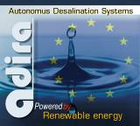
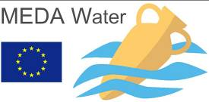
Within the framework of the MEDA Water Programme
The ADIRA Project is organising the WORKSHOP:

Autonomous Desalination Systems (ADS)
On Wednesday, the 28th of May 2008, in Athens

ADIRA WORKSHOP REGISTRATION FORM

Yes, I would like to participate in the ADIRA WORKSHOP √
My details are shown below:

First Name
Surname
Title (Mr/Mrs/Dr/Prof,..)
Profession
Affiliation
Postal Address
Telephone
Email

Please fill the form and send it to: psol@aua.gr, with subject: REGISTRATION ADIRA
REGISTRATION form is also available in: www.adira.info or www.adira.gr
**The system will reply by sending you your registration number.

